CS 255 System Design Document

This template lays out all the different sections that you need to complete for Project Two. Each section has guidance to prompt your thinking. You will need to continually reference the interview transcript as you work to make sure that you are addressing your client’s needs. There is no required length for the final document. Instead the goal is to complete each section based on what your client’s needs are. Remove this note when you are finished, and replace all bracketed text with the relevant information.

UML Diagrams

UML Use Case Diagram
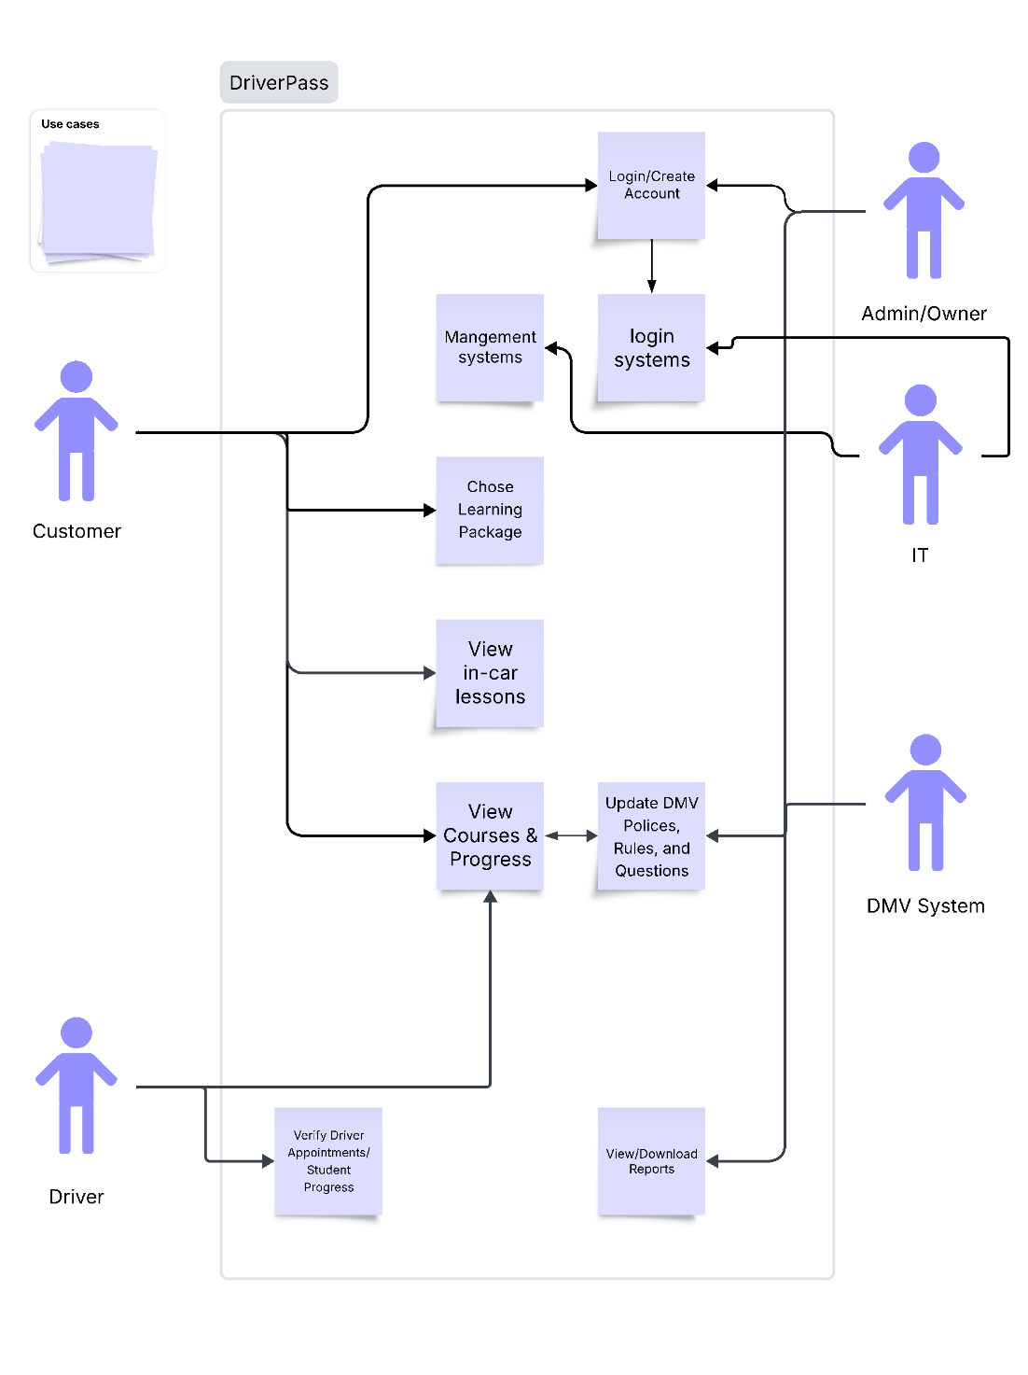

UML Activity Diagrams
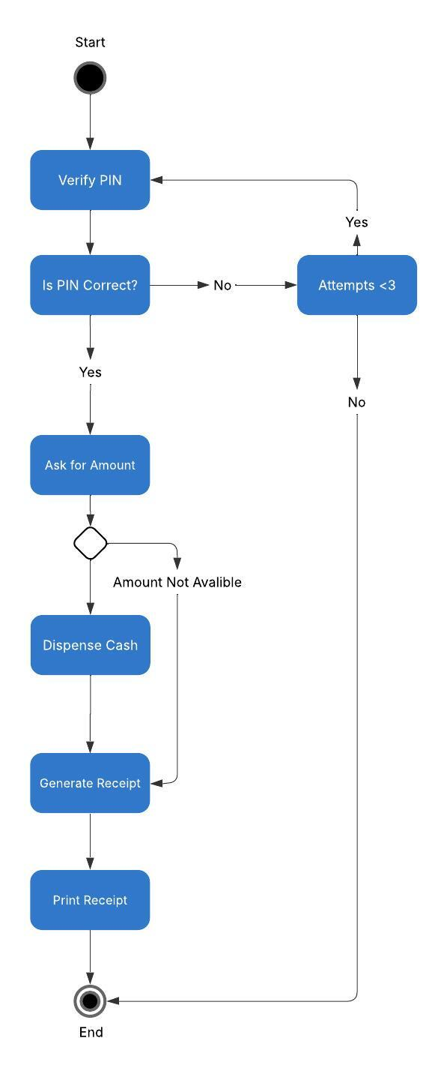
Login-
Driver Ed: checkout
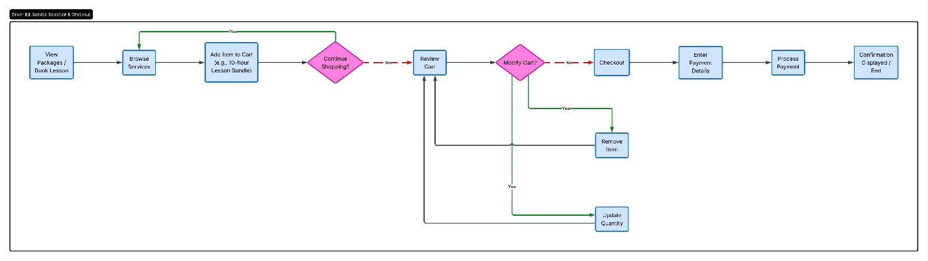

UML Sequence Diagram
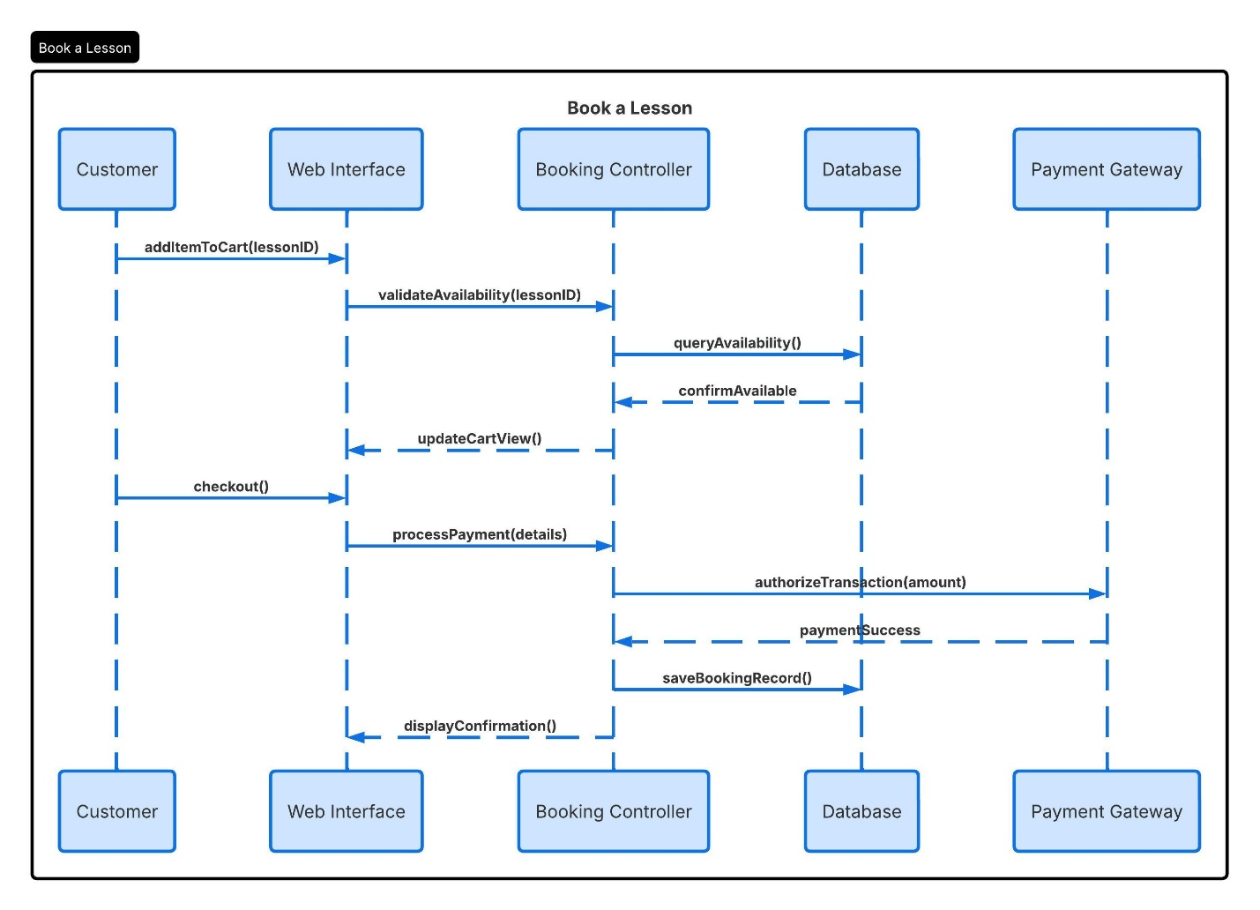

UML Class Diagram
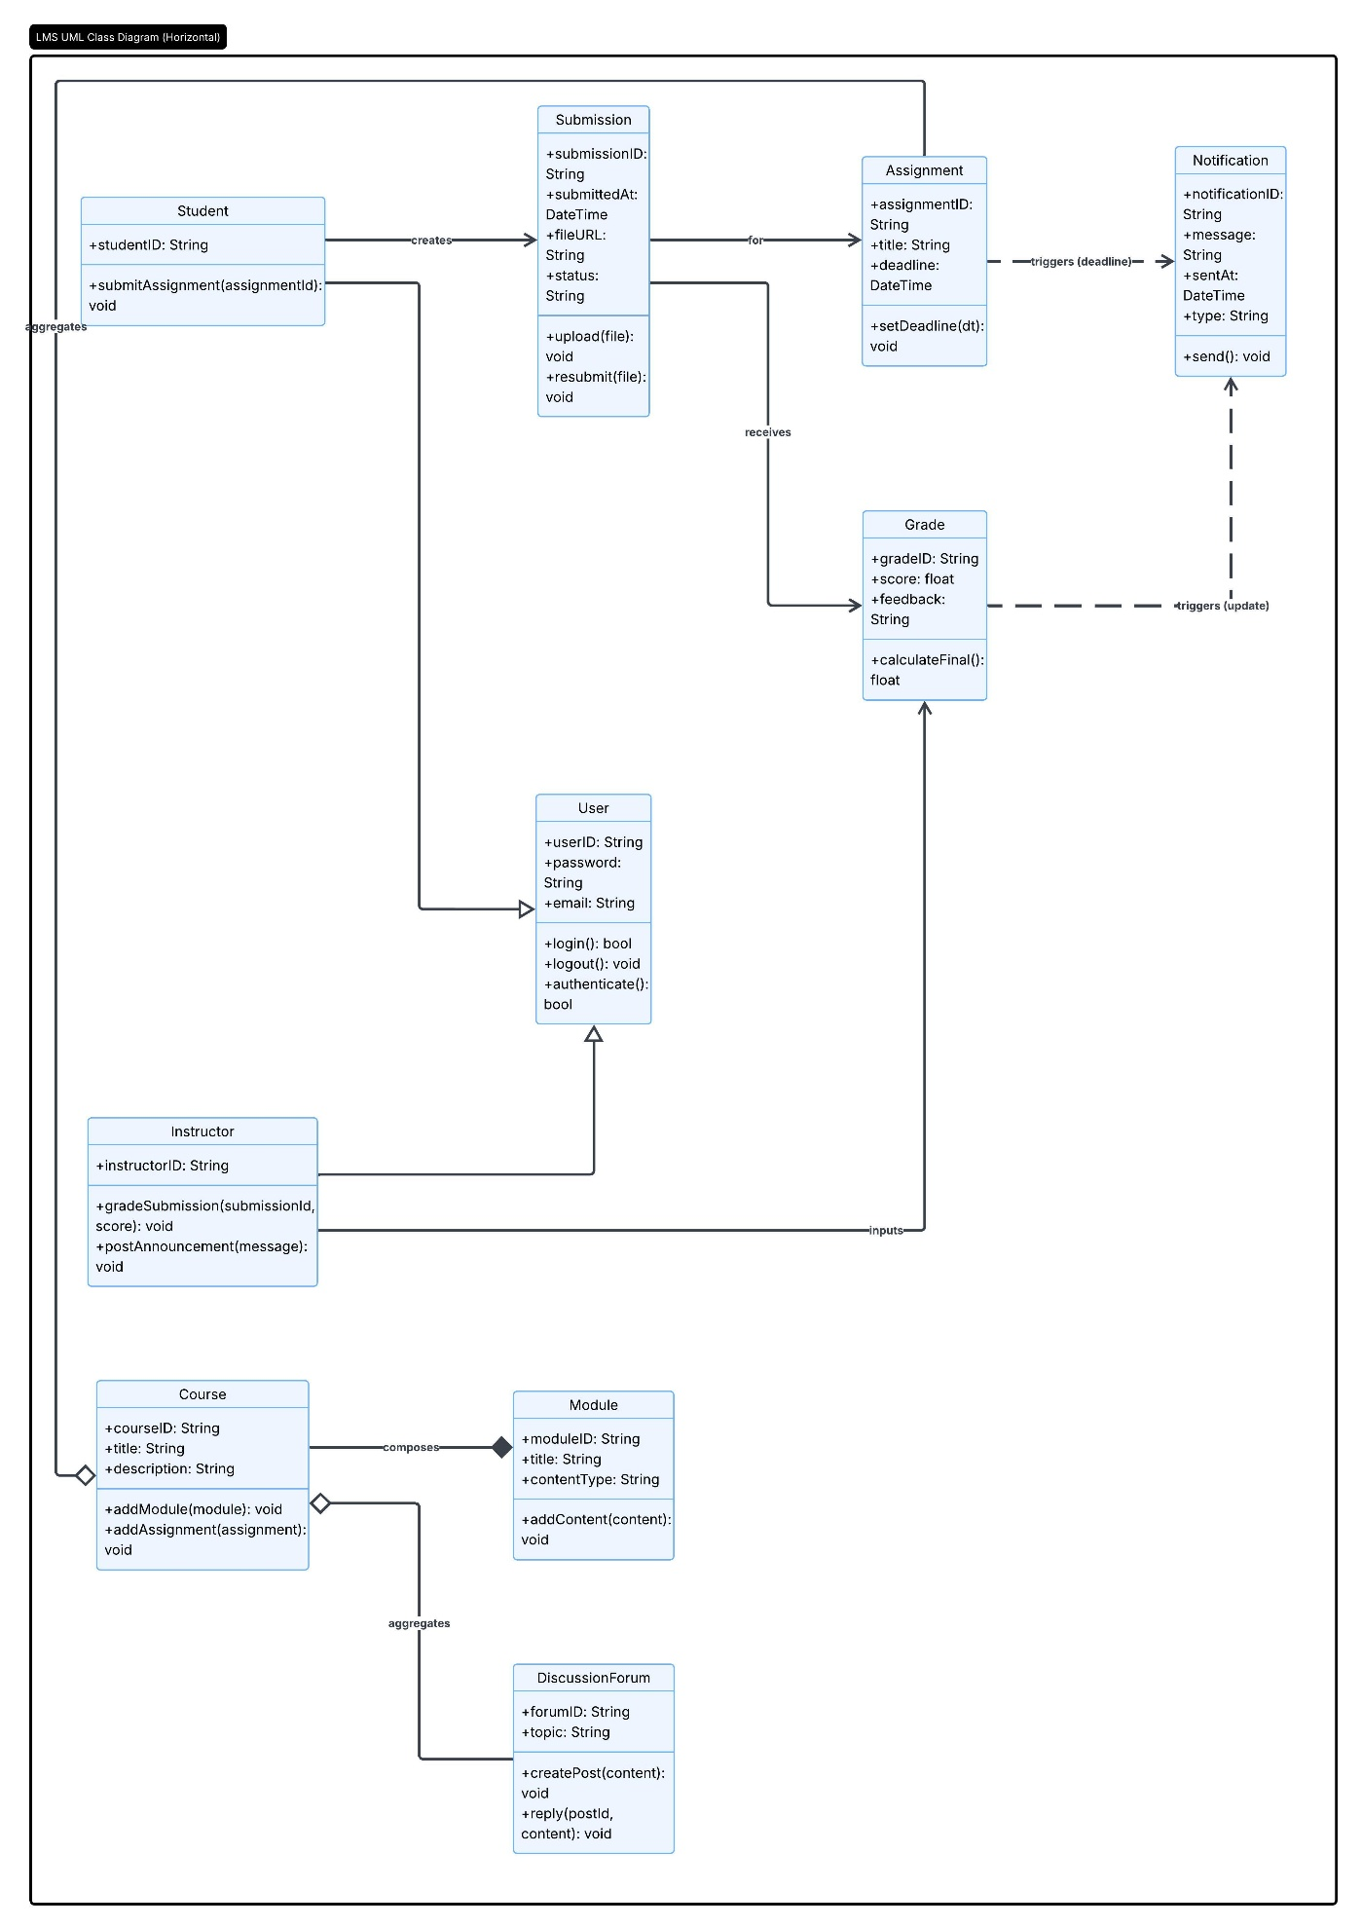

Technical Requirements
Hardware Requirements
- Web/Application Servers: High-performance servers capable of handling concurrent user sessions for students, instructors, and admin/owners.
- Database Server: Dedicated storage hardware with high I/O throughput to manage student progress, course modules, and grade data.
- Network Infrastructure: High-speed internet connectivity and load balancers to ensure 24/7 availability and traffic surges during peak usage times.
- Client Devices: Support for a variety of end-user hardware, including desktops, laptops, and mobile devices to meet the mobile usability requirements.
Software Requirements
- Operating System: Server-side OS to host the application and database.
- Database Management System (DBMS): A relational database to maintain data integrity for grades, submissions, and user accounts.
- Backend Framework: A robust programming environment to execute the controller logic for booking lessons and processing grades.
- Frontend Technologies: HTML5, CSS3, and JavaScript frameworks to ensure a responsive web interface for viewing courses and progress.
Tools and Integration Requirements
- Payment Gateway API: Integration with a secure third-party service (e.g., Stripe or PayPal) to process transactions for learning packages as shown in the checkout workflow.
- External System Interfaces: APIs to facilitate data exchange with the DMV System for updating policies and rules.
- Security Tools: Implementation of SSL/TLS encryption for all data in transit and multi-factor authentication (MFA) tools to satisfy user authentication requirements.
- Notification Service: An SMTP server or third-party email/SMS API (e.g., SendGrid or Twilio) to trigger automated alerts for deadlines and grades.
Infrastructure Requirements
- Cloud Hosting/Deployment: A scalable cloud environment to support the scalability and recoverability nonfunctional requirements.
- Backup and Recovery: Automated off-site backup solutions to ensure that student submissions and academic records can be restored in the event of a failure.
- Monitoring and Analysis: Tools to track system performance and user engagement, supporting the “View/Download Reports” use case for administrators.

